investigating the impact of airbnbs on small towns in montana

Austin Smith

Table of Contents

Introduction 2

Literature Review 4

Research Questions and Hypotheses 8

Part 1: Statewide Correlation Analysis 8

Part 2: Gardiner and West Yellowstone Descriptive Analysis 8

Data Sources 9

Analysis 10

Part 1: Statewide Correlation Analysis 10

Part 2: Gardiner and West Yellowstone Descriptive Analysis 13

Population and Age Distribution 20

Median Household Income, Median Home Values, and Proportion of Renters to Owners 22

Summary of Observations 25

Discussion 26

Limitations 27

Conclusion 28

Appendix: Correlation Results 30

Works Cited 32

# Introduction

If you enter a search term into Google related to the rise of Airbnb, you’ll likely see headlines that feel overstated at first blush.[1] *How Airbnb Took Over the World! How Airbnb and Travelers are Redefining Travel. Airbnb’s Success is Forever Changing the Way We Stay.* But upon further investigation, the hype seems justified. The numbers speak for themselves: when Airbnb went public, it was already considered a mega-cap stock and its first day of public trading shot its value past the $100 billion mark. As of the end of 2021, Airbnb was valued at $115 billion (Carmichael, 2021). And the company is not done growing. Airbnb leadership pins the company’s total addressable market at $3.4 trillion (yes, with a *t).* Granted, it competes in that market alongside behemoths in the hotel and hospitality industry, but its potential for growth looks promising. There are currently about 6 million “hosts” on Airbnb – individuals who rent out anything from rooms in their homes to their entire properties. Unlike most of its competitors in the hospitality industry, Airbnb’s business model shields it from the costs of real estate development and maintenance. Its revenue is generated from the 3% service fee it skims from hosts and the 14% service fee it charges to guests (Airbnb, 2020). Drawing new hosts to the platform promises nearly pure profit to the company.

With great success comes great controversy. Proponents of Airbnb – and other platforms that peddle short-term rentals, such as VRBO – argue that it boosts local economies by bringing in rental fees and drawing more people to bars and restaurants. They also argue that short-term rentals tend to be located in neighborhoods that aren’t traditionally “touristy”, so their presence democratizes the positive effects of tourism, spreading out vacationers’ dollars (Guttentag, 2018). Critics cite a small but growing body of research that suggests and, in some cases, provides causal support for the idea that short-term rentals drive up long-term rental rates and home prices, lead to more crime, and weaken the social fabric of a community (Bivens, 2019).

Little research has been done to probe how the rise of Airbnb has impacted towns with especially small populations, though one might posit that the effects could be massive. In a small town, even a minor decrease in the long-term housing supply might have ripple effects, decreasing the pool of potential employees and negatively impacting the public education system’s budget. In this report, I source data that can help us understand how Airbnbs might be impacting small towns in Montana, defined as those with populations below 2,500 people. As case studies, I delve deeply into the recent experiences of two particularly touristy towns that play host to an outsized number or Airbnbs per resident – Montana’s two gate towns to Yellowstone: Gardiner and West Yellowstone.

I consider, first, how the number of Airbnbs in small towns across Montana are correlated with median household income, median property values, and the distribution of age cohorts in the town. Then, I narrow my focus to Gardiner and West Yellowstone. The two make for an interesting point of comparison; Gardiner has never regulated nightly rental properties, but West Yellowstone has always restricted them to the commercial district of its town. Both areas have low populations and cannot readily respond to a housing pinch. In this section of analysis, I explore how the growth of Airbnbs in both towns have changed alongside median household income, median property values, age distribution of residents, population, and the number of renter- vs. owner-occupied homes.

The statewide correlation analysis yielded statistically significant results for the relationship between the number of Airbnbs per resident in a town and the percentage of the population belonging to several age cohorts. The analysis provides evidence that there is a negative relationship between a higher number of listings per person in a town and the percentage of young people in a town, while a positive relationship exists between a higher number of listings per person in a town and a higher percentage of residents in older cohorts. Similar results were also present in the analysis of Gardiner and West Yellowstone; both towns have experienced decreasing populations alongside an increase in the number of Airbnbs, and that decrease in population has been concentrated in younger age groups. In addition, trend analysis shows that Gardiner residents have seen an increase in median household income values alongside the expansion of Airbnbs, while West Yellowstone residents, who may only host an Airbnb if they own property in the commercial district of town, have not experienced similar income increases. The results suggest that we may anticipate further population declines in small towns that attract more Airbnb listings. For the populations that remain, though, they may see their annual incomes increase if the town does not regulate where Airbnbs may exist.

# Literature Review

Most research to date on the impacts of short-term rentals has focused on their impact on local housing markets. For example, researchers from the Department of Spatial Economics at the University of Amsterdam studied the effects of short-term rental regulations on the housing market in 18 cities within Los Angeles County. They found that, in cities that instituted home sharing ordinances aimed at reducing the number of short-term rentals available, both home prices and rental rates fell by 2%. Their estimates imply large effects of platforms like Airbnb on property values, particularly those in touristy areas. Case in point: their findings show that increased Airbnb listings were associated with a 15% rise in home prices within about a mile radius of Hollywood’s Walk of Fame (Koster et al., 2021).

Researchers from the University of Oregon found similar results within small cities (population <100,000) in Oregon. Their analysis showed that Airbnb rentals placed additional pressure on an already strained supply of affordable housing (DiNatale et al., 2018). Likewise, researchers from Canada’s McGill University have conducted spatial analysis of short-term rental services. Their findings show that Airbnb activity is highly concentrated in metropolitan areas (Toronto, Montreal, and Vancouver), but that growth rates of listings are substantially higher in small towns and rural areas than in cities. Contrary to the rhetoric of “home sharing”, nearly half of short-term rental revenue in 2019 in Canada was generated by commercial operators who owned and managed multiple listings (Combs et al., 2020). Their study suggests that rural residents may lack the resources to take advantage of potential revenue streams from hosting short-term rentals, even though those residents bear the burden of rentals’ impacts on local housing markets.

Researchers from the University of Montana’s Institute for Tourism and Recreation Research have conducted qualitative surveys of both residents and tourists to parse out the benefits and downsides of short-term rentals across Montana. Their results mirror those of the studies cited previously: short-term rentals increase financial well-being for hosts, but may limit housing supply and drive up local home and rental costs (Bigart et al., 2021).

Perhaps the most robust analysis of the relationship between short-term rental listings and housing prices comes from a 2020 working paper produced by a group of researchers from the University of Southern California and the National Bureau of Economic Research. They aimed to determine, with as much specificity as possible, the quantitative impact Airbnb listings has on housing prices throughout the U.S. A multitude of variables can impact the housing market, so teasing out Airbnb’s specific effect on housing rates is a statistically acrobatic move. In their study, the researchers controlled for factors like gentrification and economic trends within the housing market to isolate the part of housing costs driven solely by changes in Airbnb supply. Their analysis centers on an intuitive line of reasoning: they argue that if a zip code is “touristy” (has lots of bars and restaurants), and if awareness of Airbnb increases (as measured by Google search index for keyword “Airbnb”), then any jump in Airbnb supply in that zip code is likely driven by an increase in demand for short-term rentals, rather than other local economic conditions. According to their results, a 10% increase in Airbnb listings is causally associated with a 0.18% increase in rental rates and a 0.26% increase in home prices.

Beyond rental and home prices, research from Northeastern University suggests that the proliferation of home-sharing platforms for short-term rentals is associated with increased crime. In fact, their research, which focused on neighborhoods in Boston, found that an increase in Airbnb listings led to more violence in neighborhoods in the following years, suggesting that the prevalence of short-rentals “erodes the natural ability of a neighborhood to prevent crime” (Ke et al., 2021). Present and involved neighbors, it seems, are important in cultivating safe communities.

Other qualitative studies show that a proliferation of short-term rental listings in an area can decrease the sense of community that residents feel in their neighborhoods, weakening what one might call the “social fabric” of a city or town. Some researchers have suggested reframing the rise of short-term property rentals from one of “home sharing” to one of “neighborhood sharing”, which recognizes the fact that the prevalence of short-term rentals impacts an entire community, changing who can live there and dictating who can work there, go to school there, raise their kids there, and grow old there (Rae, 2019).

In that vein, researchers from McGill conducted an exploratory case study on short-term rentals in New York City where they argue that Airbnb has introduced novel revenue streams, but the positive effects have been geographically uneven, benefiting management groups at the expense of long-time residents (Wachsmuth & Weisler, 2018). Researchers from the University of San Francisco found similar results via in-depth interviews they conducted with residents in four areas of Oahu that have seen particularly high increases in short-term rentals in recent years, partly due the rise of platforms like Airbnb. Overall, the interviewees’ perceptions of short-term rentals were negative, citing feelings that they have increased housing costs, destroyed the local culture, damaged environmental resources, and led to more annoying disturbances like loud parties and litter. In short, the interviewees reported that Airbnbs were causing them to enjoy their neighborhoods less (Park & Agrusa, 2020).

Overall, the literature agrees: both qualitative and quantitative studies show that short-term rentals are likely to afford financial benefits to hosts, but that benefit comes at a cost – housing and rental prices increase and local residents report decreased quality of life in their neighborhoods. The downstream effects of less housing stock due to an abundance of short-term rentals in *rural* areas is not well studied, though findings from the University of Minnesota suggest that housing is critical to the well-being of rural communities. Affordable housing is the pre-requisite for population levels that can support high-quality education systems and economic growth (Ziebarth, 2015). In the following analysis, I attempt to fill in some of the research gap by focusing specifically on the impacts of Airbnb on small towns in Montana.

# Research Questions and Hypotheses

## Part 1: Statewide Correlation Analysis

In part one of my analysis, I examine the relationship between the current number of Airbnbs in small Montana towns (defined as those with populations <2,500) and the following three metrics: median property value, median household income, and the age distribution of residents. I break the age cohorts into several groups: under 18, 18-34, 35-54, 55-74, and 75 and older. Based on the literature analysis, I hypothesize that:

1. A higher number of Airbnb listings will be correlated with higher median household income values and higher median property values.
2. A higher number of Airbnb listings will be negatively with the percentage of young people in a town (ages under 35) and positively correlated with the percentage of older age cohorts in a town (ages over 55).

## Part 2: Gardiner and West Yellowstone Descriptive Analysis

In part two of my analysis, I narrow my focus and investigate Montana’s two gate towns to Yellowstone National Park: Gardiner and West Yellowstone. Both towns have low populations (800-1,200 residents), are remote from large population centers, and survive, largely, on income derived from tourists. Anecdotal evidence suggests that short-term rentals like Airbnbs have exploded in the past 5-7 years in the two towns. Based on my analysis, there are upwards of 350 nightly rentals properties within a 30-mile radius of Gardiner and more than 400 within a similar radius of West Yellowstone. Gardiner, proper, only has about 450 homes and West Yellowstone, proper, boasts about 650. These figures would be larger if the surrounding area were included in the housing stock, but still – Airbnb rentals have captured a substantial portion of the housing stock in both towns.

I hypothesize that, as Airbnbs have increased in both towns, the housing stock has shrunk and home prices have risen, pushing out lower-income families and leading to an overall decline in both populations. I also predict that the remaining population has realized higher median household income values because of the revenue generated from hosting. Because West Yellowstone has regulated Airbnbs, I expect the impact on housing prices, population, and income to be less pronounced in West Yellowstone than in Gardiner.

# Data Sources

The data for this analysis comes from the following sources:

1. Airbnb website scrape for current listings in Gardiner, West Yellowstone, and all towns with populations below 2,500 across the state.[2]
2. DataUSA, which aggregates data from the Bureau of Economic Analysis, Bureau of Labor Statistics, U.S. Census, and Department of Urban Housing and Development, among other sources.[3] From the API, I pull population and age distribution data, median household income, and median home value for all towns in my analysis, as well as the number of homes in Gardiner and West Yellowstone that are renter- and owner-occupied.
3. Montana Office of Tourism and Business Development Lodging Facility Use Tax, which is used to estimate historical Airbnb listing figures for Gardiner and West Yellowstone.[4]
4. AirDNA, a Airbnb data aggregator, which provides the number of Airbnb listings from Q4 of 2018 to Q4 of 2021 for Gardiner and West Yellowstone.[5] Note that listing data prior to the fourth quarter of 2018 is locked behind a (steep) paywall on the site.

# Analysis

## Part 1: Statewide Correlation Analysis

In the statewide correlation analysis, I restrict my data set to towns that have at least one Airbnb on account of the fact that there were many small towns in Montana with zero Airbnb listings. This restriction yields 118 towns in total. The minimum listings per person in the sample of towns is 0.00070 per person, i.e., one listing for every 10,000 people (though, note, no town in the sample has more than 2,500 people). The maximum listings per person is 1.07890 per person: Jardine, MT, a small community next to Gardiner. The mean listings per person is 0.04684, or nearly 5 listings per 100 residents, and median listings per person is 0.01360, or a bit over 1 listing per 100 residents. The fifteen towns with the highest number of listings per person are presented in Table 1.

Table 1. Top 15 towns ordered by number of Airbnb Listings per resident.

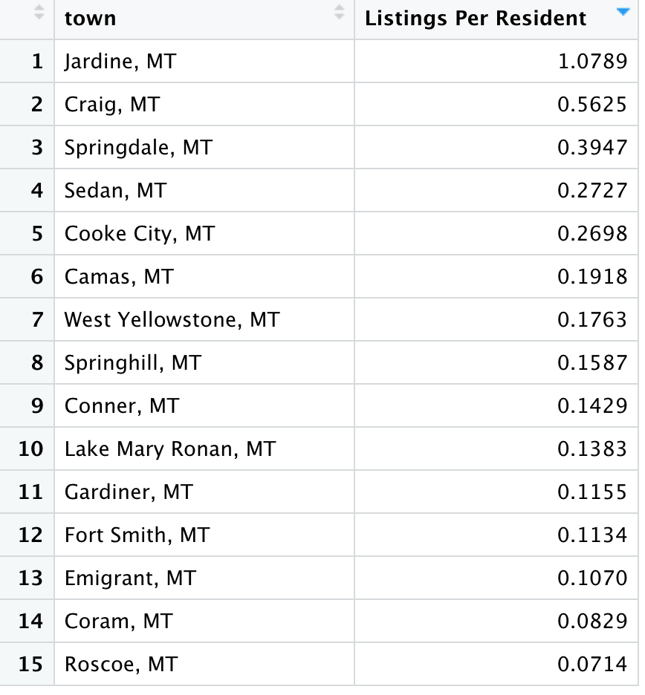

Each of the variables I considered – median property value, median household income, and the proportion of residents within each age group – were right skewed; there were many data points on the lower end of the spectrum with a handful of higher values. I conducted both Spearman’s rank correlations, for which normality of data is not assumed, and Pearson’s linear correlations, for which I log transformed the skewed variables so that they were more normally distributed. Both correlation methods require that there is a monotonic or linear relationship present between the variables, which was only loosely met in my data set. This is illustrative of the fact that there are many different variables that impact median household income, property values, and age distributions of residents. Airbnb listings, it appears, are playing only a small, if any, role in influencing those variables.

Both correlation methods yielded statistically significant results for the relationships between listings per person in a town and:

* The percentage of the population under 18;
* The percentage of the population between ages 18 and 34; and
* The percentage of the population between ages 55 and 74.

Pearson’s correlation found a statistically significant result between listings per person and the percentage of the population aged 35-54, and Spearman’s correlation found a statistically significant relationship between listings per person and the percent of the population 75 and older, but in both cases the relationship was so slight as to be negligible.

Visualizations of the correlation results are included in the appendix and summarized in Table 2. Both correlations produced similar findings: more listings per person in a town is associated with a lower percentage of people under 18 and between ages 18 and 34; conversely, more listings per person in a town is positively associated with the percentage of residents in a town ages 55-74.

Table 2. Summary of statistically significant correlative relationships between variables in statewide correlation analysis.

|  |  |  |  |  |
| --- | --- | --- | --- | --- |
| Relationship | Correlation Method | Correlation Coefficient | P-Value | Interpretation |
| Listings per Person and Percentage of the Population under 18 | Spearman’s | -0.33 | 2.2e-16 | Moderate, negative relationship |
| Listings per Person and Percentage of the Population under 18 | Pearson’s | -0.31 | 2.2e-16 | Moderate, negative relationship |
| Listings per Person and Percentage of the Population ages 18-34 | Spearman’s | -0.26 | 2.2e-16 | Weak, negative relationship |
| Listings per Person and Percentage of the Population ages 18-34 | Pearson’s | -0.21 | 6.9e-12 | Weak, negative relationship |
| Listings per Person and Percentage of the Populations ages 55-74 | Spearman’s | 0.35 | 2.2e-16 | Moderate, positive relationship |
| Listings per Person and Percentage of the Populations ages 55-74 | Pearson’s | 0.32 | 2.2e-16 | Moderate, positive relationship |

There were no statistically significant results for the relationships between listings per person in a town and either median household income or median property values.

## Part 2: Gardiner and West Yellowstone Descriptive Analysis

Figure 1. Town Plat of West Yellowstone, sourced from town website, which shows the commercial sections of town where Airbnbs are allowed (B-3, B-4) and the residential zone where Airbnbs are not permitted (R1-R4).

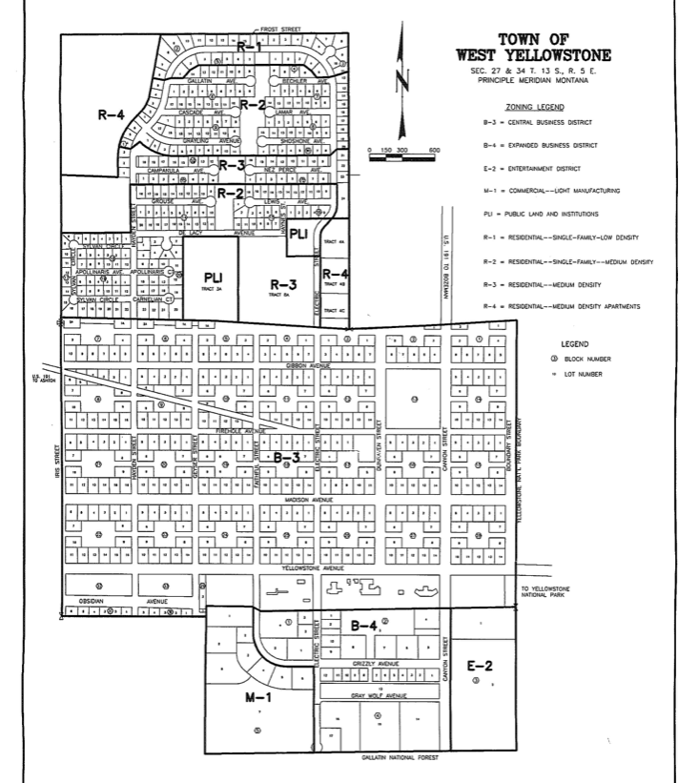Per my conversation with West Yellowstone’s Finance Clerk, Peggy Russell, the town of West Yellowstone restricts where nightly rentals may be located to commercial districts of the town (zones B-3and B-4 in Figure 1). A simple search on the Airbnb website shows that the town enforces this rule; residential zones do not have Airbnbs (see Figure 2).

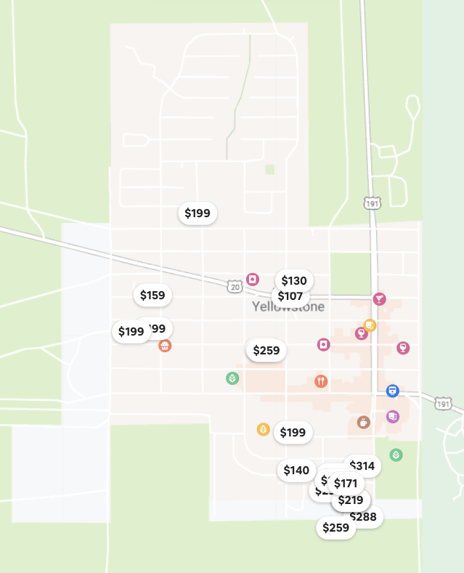

Figure 2. Airbnb Listings for town of West Yellowstone as of 2/22/22. Note that there are no listings in the residential zones, per city ordinance.

Gardiner does not have any similar town ordinance (it is not, technically a town, but rather an unincorporated community); Airbnbs may be located anywhere in the town. Short-term rentals have been available in both towns for over a decade, though anecdotal evidence from residents suggests that Airbnbs have become more popular – and more proliferate – in recent years.

Reliable historical Airbnb listing data is hard to come by unless one is willing to pay a subscription service to a data aggregating firm. I was able to source historical listing figures for both towns from AirDNA, a short-term rental analytics company, on their free platform. Unfortunately, that data only goes back to Q4 of 2018 and figures from 2020 are anomalous due to the COVID-19 pandemic. To fill in this data gap, I employed historical revenue data from the 4% Lodging Facility Use Tax (aka “Bed Tax”) from Montana’s Office of Tourism and Business Development, which applies to hotels as well as nightly rentals like Airbnbs. The state notes that their reported figures are affected by “rate increases, delinquencies, and other factors.” Table 3 below exhibits how Bed Tax revenue figures have shifted since 2006, generally increasing save for the onset of the global pandemic.

Table 3. Bed Tax Revenue since 2006 in Gardiner and West Yellowstone. [6]

|  |  |  |  |  |
| --- | --- | --- | --- | --- |
|  | **GARDINER** | | **WEST YELLOWSTONE** | |
| Year | Bed Tax Revenue | Bed Tax Revenue Annual Growth | Bed Tax Revenue | Bed Tax Revenue Annual Growth |
| 2006 | $ 114,908.86 |  | $ 736,853.40 |  |
| 2007 | $ 144,244.24 | 20% | $ 813,791.28 | 9% |
| 2008 | $ 190,118.24 | 24% | $ 1,114,227.07 | 27% |
| 2009 | $ 198,688.57 | 4% | $ 1,171,932.65 | 5% |
| 2010 | $ 218,473.82 | 9% | $ 1,406,799.94 | 17% |
| 2011 | $ 218,476.35 | 0% | $ 1,439,127.32 | 2% |
| 2012 | $ 229,684.00 | 5% | $ 1,482,540.00 | 3% |
| 2013 | $ 234,514.00 | 2% | $ 1,678,832.00 | 12% |
| 2014 | $ 274,313.00 | 17% | $ 1,911,889.00 | 12% |
| 2015 | $ 310,028.00 | 13% | $ 2,109,848.00 | 9% |
| 2016 | $ 421,452.00 | 36% | $ 2,337,835.00 | 10% |
| 2017 | $ 439,314.00 | 4% | $ 2,447,071.00 | 4% |
| 2018 | $ 456,476.00 | 4% | $ 2,538,544.00 | 4% |
| 2019 | $ 506,251.00 | 11% | $ 2,614,552.00 | 3% |
| 2020 | $ 357,904.00 | -29% | $ 1,809,959.00 | -44% |
| 2021 | $ 689,050.00 | 93% | $ 3,198,095.00 | 43% |

Overlaying Bed Tax data with two years of historical Airbnb listing offers the ability to draw a trendline that, while based on very little information, seems plausible in light of anecdotal evidence from my conversations with locals in both towns. In Figure 3 below, Bed Tax revenue by town is displayed alongside its annual rate of change. In the right-hand panel, the solid line represents AirDNA data – the data points on which the trendline is based. The dashed line is a loess curve fitted back to 2012. It should be noted that this trendline is dubious, at best, as it is based on a very small sample of historical listing data. However, it is reassuring to note that the trend appears to mimic that of the Bed Tax revenue by town, with Gardiner exhibiting a steeper rise in revenue than West Yellowstone.



Figure 3. Bed Tax Revenue by town (bar chart, with lines to represent annua rate of change) plotted alongside historical listing data (right pane), which is estimated back to 2012.

Using this trendline, I overlay annual Bed Tax revenue (in purple) with the estimated number of Airbnb listings in each town (bars) in Figure 4.



Figure 4. Bed Tax revenue by town is plotted in purple alongside the estimated number of Airbnb listings in each town over time. Note that the colored bars are true values for Airbnb listings; the grey bars are estimates.

Based on these estimates, both towns, regardless of local ordinance, have seen a steady increase in Airbnb listings over the past decade. The number of listings in West Yellowstone has increased at a slower pace than in Gardiner, perhaps because of its ordinance restricting where nightly rentals can be located.

In the following sections, I describe how each town’s population, age distribution, median home value, median household income, and percent of homes occupied by renters vs. owners has changed alongside the growth of Airbnbs. The trends described in the following section mirror the timeframe of the growth in Airbnbs illustrated above.

### Population and Age Distribution

Populations in both Gardiner and West Yellowstone have decreased in recent years, with West Yellowstone losing nearly 36% of its population since 2013 and Gardiner losing nearly 19%.



Figure 5. Town populations since 2013 have decreased dramatically.

In addition, both towns have seen the greatest percent decrease in the proportion of their populations under 18 years of age, as compared to other age cohorts (see Figure 6).



Figure 6. The most dramatic decrease in population has been for age cohort 0-18 years old.

The only appreciably growing age cohort is 18-34 year olds in Gardiner. Other age groups in both towns have either decreased as a percent of the total population or remained relatively flat.



Figure 7. Age distribution as a percentage of the total population, by town, which shows that most age cohorts are decreasing or level, exhibiting a generally aging population.

### Median Household Income, Median Home Values, and Proportion of Renters to Owners

Gardiner and West Yellowstone exhibit opposite trends in median household incomes. Gardiner has had a higher median household income than West Yellowstone, but that gap grew from 2013 to 2018 before dropping off sharply in 2019. West Yellowstone experienced the opposite trend, falling to a nadir in 2016 where incomes stabilized before beginning to rise again in 2018.



Figure 8. Median household incomes by town show that Gardiner is generally wealthier, though recent trends suggest the towns’ values may be converging.

By 2019, the median home values in both towns returned to figures roughly in line with where they were in 2013. And, again, the towns experience opposite trends; Gardiner’s median home price rose to a peak of over $320k in 2018 while West Yellowstone’s fell to about $240k between 2015 and 2017 before rising again to about $280k, ending in line with Gardiner’s median home price.



Figure 9. Median home values by town have converged roughly to where they were in 2013, though they experienced opposite trends in the interim years.

The number of homes occupied by owners versus those occupied by renters is a final intriguing point of comparison. In Gardiner, the overall number of owner-occupied homes has decreased to the point that there are now a greater number of renter-occupied homes than owner-occupied homes in the town. In West Yellowstone, the total number of owner-occupied homes has been flat while the number of renter-occupied homes has decreased. There are now a roughly even number of owner- and renter-occupied homes in West Yellowstone, which suggests that it has been mostly renters who have moved out of the town.



Figure 10. Number of homes occupied by renters and home owners by town. Renter-occupied homes (which, do not include Airbnb rentals) are increasing in Gardiner while owner-occupied homes are decreasing, while in West Yellowstone owner-occupied homes have remained flat while renter-occupied homes have decreased.

### Summary of Observations

The preceding figures have illustrated:

1. Airbnb listings have most likely risen in both towns since 2015, though the number of listings has likely risen faster in Gardiner than in West Yellowstone.
2. At the same time, both towns have experienced dramatic decreases in populations, particularly West Yellowstone. The under 18 age cohort has fallen the most precipitously in both towns since 2013 while other age cohorts have fallen slightly or remained flat.
3. Median household income has been higher in Gardiner than in West Yellowstone, with opposite trends occurring in each town; Gardiner’s median household income has mostly risen alongside the growth of Airbnbs, while West Yellowstone’s has mostly decreased or stayed flat. This statement is only an observation and is not meant to imply a causal relationship between the two trends.
4. As the number of Airbnbs in both towns has risen, Median home values have moved in opposite directions for both towns, but have settled to roughly equivalent figures recently.
5. In West Yellowstone, the number owner-occupied homes have been flat since 2013 while renter-occupied homes have decreased. In Gardiner, the opposite has occurred: owner-occupied homes have slowly decreased in number while renter-occupied homes have increased.

# Discussion

There are a multitude of factors that influence population movements, income, and property values. A much more robust data collection and analysis process would be required to elucidate any causative effects Airbnb might be having on any of the metrics illustrated in this report.

However, the data does support a few themes. On a statewide basis, more Airbnb listings per person in a town is correlated with fewer young people and more people in older age cohorts. This effect seems to be more extreme when we narrow our focus to two particularly touristy towns with exceptionally high numbers of Airbnbs. Both Gardiner and West Yellowstone have seen a significant decline in populations, especially of young people. Though, again, this is only an observation and not an asserting of a causative relationship.

Impacts of Airbnb on household income and median property values are unclear. On a statewide basis, Airbnb listings do not have a statistically significant association with either median household income or median property values. By narrowing in on Gardiner and West Yellowstone, we can see that median household incomes have mostly risen in Gardiner, the town without zoning laws related to Airbnbs, while they have been consistently lower in West Yellowstone where Airbnbs are restricted to the commercial district of town, which perhaps limits the workaday resident’s ability to take advantage of novel revenue streams via Airbnb. Median property values have not fluctuated in a consistent manner in either town.

# Limitations

As stated previously, I could list dozens of factors that might influence such broad trends like population movements, household income, and property values. The primary limitation of this report is that it makes no effort to tease out the specific effects of Airbnb listings on any of those metrics; rather, it simply illustrates what associations might exist between the number of listings in a town and those variables. In order to pull out any causative relationships, a much more robust data collection and analysis would have to be undertaken.

It should also be noted that the approach taken in this report has limitations for extension to other geographies or larger geographies. The way that Airbnb returns listing results is not an accurate representation of how many listings should be attributed to a given town. The listing results for nearly every town in the data set had to be manually fixed because Airbnb cast either too wide or too narrow a net when it returned listing results, even when I wrote code to direct the site to zoom in on a town to narrow results. For the size of this data set, manually fixing listing results was annoying, but not impossible. If this approach was replicated at a larger scale, manually fixing results would be a less reasonable undertaking.

# Conclusion

It seems likely that Airbnb is here to stay and will continue to have an impact on small towns with high rates of tourism and low housing stock. Judging by the result of the statewide correlation analysis, we would expect to see fewer young people in towns with more Airbnb listings, though it’s likely that trend would level out at some point. Based on the in-depth analysis of Gardiner and West Yellowstone, small towns should think carefully about how they decide to zone for Airbnbs – or not. It appears that the ability for any resident in Gardiner to host an Airbnb may have contributed to higher median household income values over the past decade, whereas the average West Yellowstone resident hasn’t been able to realize similar income gains. However, because West Yellowstone has preserved its residential districts by banning Airbnbs in residential zones, we may see longer term trends in West Yellowstone that are more conducive to a “community”, like more even age distributions in the population, compared to Gardiner. However, that development – and the fate, generally – of small towns inundated by Airbnbs remains to be seen.

# Appendix: Correlation Results

For a detailed explanation of the data processing and analysis for each correlation method, please see the accompanying R Markdown File “Correlation Analysis.”

Figure 11. Spearman's (left) and Pearson's (right) correlation results for the relationship between the number of listings per person in a town and the percentage of the town's population under 18 years old.

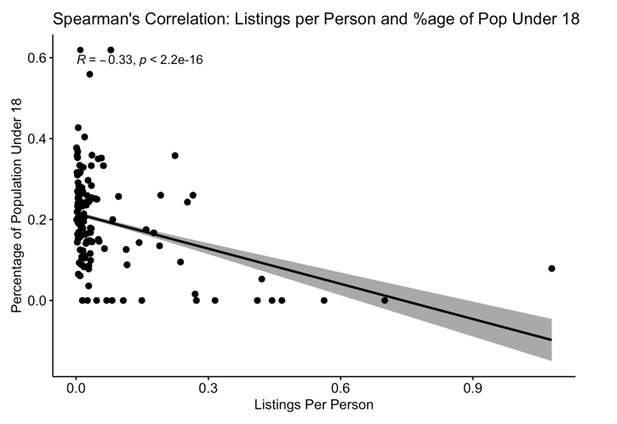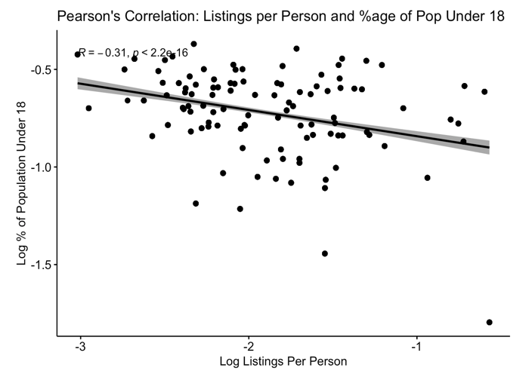

Figure 12. Spearman's (left) and Pearson's (right) correlation results for the relationship between the number of listings per person in a town and the percentage of the population ages 18 to 34.

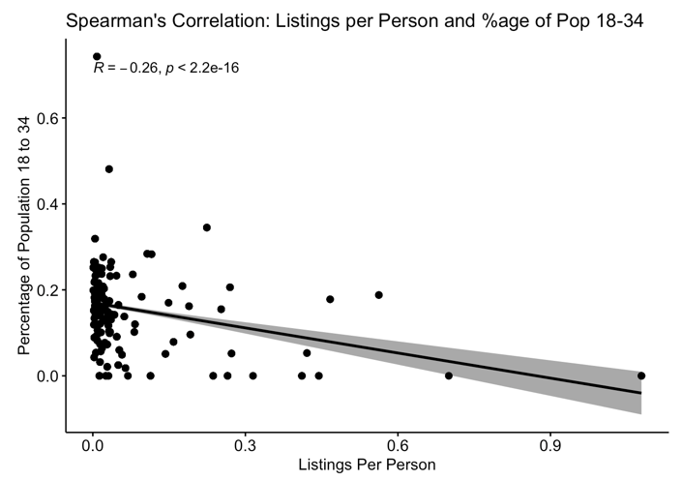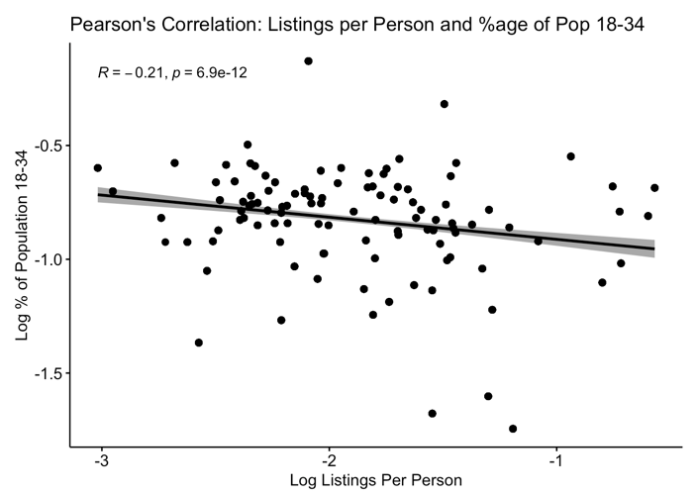

Figure 13. Spearman's (left) and Pearson's (right) correlation results for the relationship between the number of listings per person in a town and the percentage of the population ages 55 to 74.

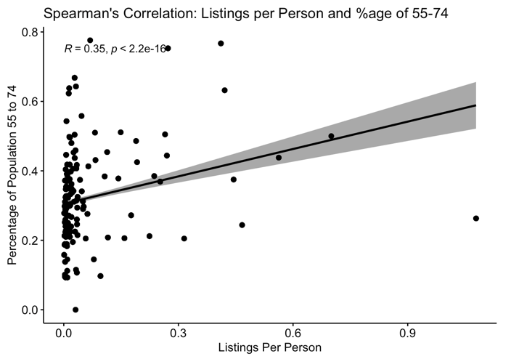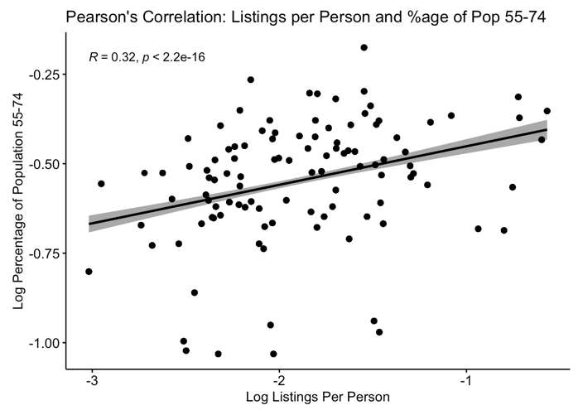

# Works Cited

Airbnb. (2020, November 16). *How much does Airbnb charge Hosts?* . Resource Center.

Bigart, E., Nickerson, N., Grau, K., Hartman, G., Jones, Z., & Sage, J. (2021). *The State of Short-Term Rentals in Montana*.

Bivens, J. (2019). The Economic Costs and Benefits of Airbnb. In *Economic Policy Institute* (Issue 2016).

Carmichael, T. (2021, December 10). *The Rise of Hosting on Airbnb*. The Motley Fool.

Combs, J., Kerrigan, D., & Wachsmuth, D. (2020). Short-term rentals in Canada: Uneven growth, uneven impacts. In *Canadian Journal of Urban Research* (Vol. 29, Issue 1).

DiNatale, S., Lewis, R., & Parker, R. (2018). Short-term rentals in small cities in Oregon: Impacts and regulations. *Land Use Policy*, *79*. https://doi.org/10.1016/j.landusepol.2018.08.023

Guttentag, D. (2018). *What Airbnb really does to a neighbourhood*. Bbc News.

Ke, L., O’Brien, D. T., & Heydari, B. (2021). Airbnb and neighborhood crime: The incursion of tourists or the erosion of local social dynamics? *PLoS ONE*, *16*(7 July). https://doi.org/10.1371/journal.pone.0253315

Koster, H. R. A., van Ommeren, J., & Volkhausen, N. (2021). Short-term rentals and the housing market: Quasi-experimental evidence from Airbnb in Los Angeles. *Journal of Urban Economics*, *124*. https://doi.org/10.1016/j.jue.2021.103356

Park, S. Y., & Agrusa, J. (2020). Short-term rental: disruptively innovative or disturbingly annoying for residents? *Asia Pacific Journal of Tourism Research*, *25*(8). https://doi.org/10.1080/10941665.2020.1778049

Rae, A. (2019). From neighbourhood to “globalhood”? Three propositions on the rapid rise of short-term rentals. In *Area* (Vol. 51, Issue 4). https://doi.org/10.1111/area.12522

Wachsmuth, D., & Weisler, A. (2018). Airbnb and the rent gap: Gentrification through the sharing economy. *Environment and Planning A*, *50*(6). https://doi.org/10.1177/0308518X18778038

Ziebarth, A. (2015). Renting in Rural America. *Family and Consumer Sciences Research Journal*, *44*(1). https://doi.org/10.1111/fcsr.12121

1. 1: <https://www.theguardian.com/technology/2019/may/05/airbnb-homelessness-renting-housing-accommodation-social-policy-cities-travel-leisure>

   2: <https://talkroute.com/the-rise-of-airbnb-taking-over-hospitality-industry/>

   3: <https://news.airbnb.com/2021-travel-trends/>

   4: <https://insights.consumer-edge.com/2020/12/airbnbs-success-in-forever-changing-the-way-we-stay/>
2. See accompanying Jupyter Notebooks for full explanation of data sourcing.
3. Full list of data sources from which the DataUSA API draws are available here: <https://datausa.io/about/datasets/>
4. Please see “State, Region, and CVB” excel available here: <https://marketmt.com/Programs/Industry-Services-and-Outreach/Lodging-Facility-Use-Tax>
5. Use search bar at this website to see historical listing data; note that most historical data is behind a paywall and was not used in this analysis: <https://www.airdna.co>
6. See “State, Region, and CVB” Excel spreadsheet from Montana Office of Tourism and Business Development. Lodging Facility Use Tax: <https://marketmt.com/Programs/Industry-Services-and-Outreach/Lodging-Facility-Use-Tax>